

Announcements

**Staff Picks on Display**

Are you looking for new book recommendations? Check out our winter Staff Picks on display at the Library. These books have been read and enjoyed by Paul Smith Library staff.



**Staff**

**Michele Lefler, Director**

[mlefler@yorklibraries.org](mailto:mlefler@yorklibraries.org)

**Louann Lucas, Volunteer Coordinator**

[llucas@yorklibraries.org](mailto:llucas@yorklibraries.org)

**Anna Paules, Library Assistant & Inter-Library Loan**

[apaules@yorklibraries.org](mailto:apaules@yorklibraries.org)

**Library Assistants**

**Lauren B.**

**Carol F.**

**Katie F.**

**Candace S.**

**Your Unwanted Glasses Will Help Someone See Better**

Donate your old, unused glasses to the Lion’s Club Recycle for Sight program. A donation box is located in the vestibule.

**A New Book is Never Far Away**

Are you in need of new books for your Kindle or e-reader? York County Libraries offers a great selection of ebooks for you to access at home and on the go. Visit yorkebranch.overdrive.com to download your next novel today!



**Need Help with Your Electronics?**

The YCL Tech GURU will be at Paul Smith Library on the first Wednesday of each month from 1:30-3:30pm. Stop by on Wednesday, January 3rd for assistance with your Laptop, Kindle and more.

**Hours of Operation**

**M/T/W: 10am - 8pm**

**TH/F/SAT: 10am – 5pm**

**Sun: Closed**

[www.yorklibraries.org/paul-smith](http://www.yorklibraries.org/paul-smith)

**Search the library catalog, renew books, place holds and more!**

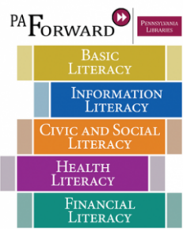

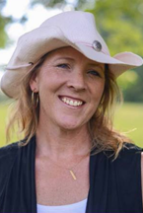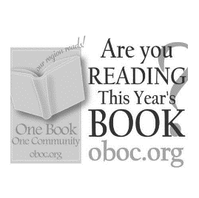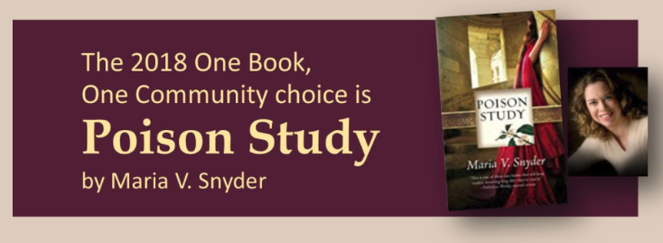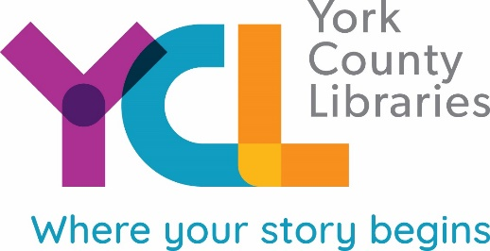

**Library to Host Publishing Workshop**

Ever wondered what it takes to see your name in print? Cara Sue Achterberg, will offer insight, resources, and inspiration to help you take your writing from in your head to out in the world. Whether your goal is to be published with online journals, print magazines, short story anthologies or even a book with an independent press or one of the ‘Big Five’ publishers, learn how to position and prepare yourself and your writing to be published. The workshop will take place January 9 at 6:30pm in the Heritage Room at Paul Smith Library.   
  
Cara Sue Achterberg is a novelist, blogger, and rescue dog foster mom who lives in New Freedom who has written three novels, I’m Not Her, Girls’ Weekend, and Practicing Normal, and one nonfiction book, Live Intentionally. For more information, blog links, and plenty of puppy pictures, visit [www.CaraWrites.com.](http://www.CaraWrites.com.)

This is a rollicking, exciting fantasy novel with a strong, intelligent female protagonist, Yelena.  Her world is authoritarian and rigid with strict laws. Yelena is offered a choice between death and becoming the leader’s poison taster.  “Sieges weather, fight together, friends forever” is a quote from the book that encapsulates Yelena’s adventures as she learns to adapt to and change her world.  On one level, this is a wonderful fantasy novel, but the deeper themes stay with readers for years. Check out a copy of the book today!

**What is the One Book, One Community: Our Region Reads! Campaign?**

Community-wide reading, or "One Book," programs are designed to promote the value of reading by recommending a compelling book that links the community in a common conversation. One Book programs encourage dialogue about a particular book, but also foster lifelong learning and the development of a strong community identity.

|  |  |  |
| --- | --- | --- |
| Jan. 1 | Library Closed |  |
| Jan. 3 | Tech Guru | 1:30-3:00pm |
| Jan.6 | Muttigrees | 10:30am-12:00pm |
| Jan. 8 | LEGO Club | 6:00-7:30pm |
| Jan. 9 | Publishing Workshop | 6:30pm |
| Jan. 10 | Coffee & Coloring | 5:00-7:00pm |
| Jan. 12 | Friday Book Club | 1:00-3:00pm |
| Jan. 15 | Adult Storytime | 12:00-1:00pm |
| Jan. 17 | Evening Book Group | 6:00-7:00pm |
|  |  |  |
|  |  |  |
|  |  |  |
|  |  |  |

**Calendar of Events**

**PAUL SMITH PRESS**

*Your Community Link*

PAUL SMITH LIBRARY NEWS, INFORMATION & EVENTS

January 2018