A Variety of Programs

Paul Smith Library is proud to offer a variety of programs for adults. Come in to

**Do you want to see your content here? We want to publish you!**

Write a poem, short story or a book review and we will consider adding it to one of our upcoming newsletters. Drop your submissions off at the Library for the Director, or email them to mlefler@yorklibraries.org

Patron Nook

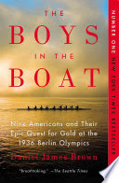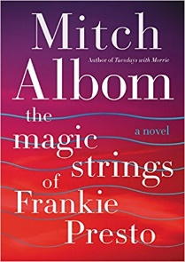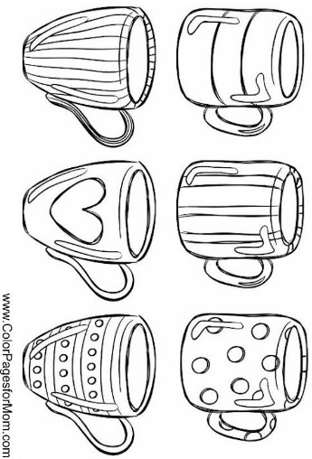 learn and socialize with other library patrons.

**Friday Book Club**

This book club is held on the second Friday of each month from 1:00-3:00pm. If you have read the book but are not a member of the club, you are welcome to join us for the discussion. To register for the club, please call the library or email [mlefler@yorklibraries.org](mailto:mlefler@yorklibraries.org)

**January Book:**

*Camino Island* by John Grisham

**February Book:**

*News of the World* by Paulette Jiles

**Adult Storytime**

Who doesn’t love a good story? At Paul Smith Library, story time isn’t just for kids anymore! Bring your lunch and enjoy listening to a story. This is an adults program held on the third Mondayof each month at Noon. No registration is required.

**Evening Book Group**

This book group is held from 6:00-7:00pm on the third Wednesday of each month. To register for the group, please call the library or email [llucas@yorklibraries.org](mailto:llucas@yorklibraries.org)

**January Book:**

*The Boys in the Boat: Nine Americans and Their Epic Quest for Gold at the 1936 Berlin Olympics* by Daniel Brown

**February Book:**

*The Magic Strings of Frankie Presto: A Novel* by Mitch Albom

**Coffee & Coloring**

This adult program provides a time for community members to come in and unwind. Enjoy a cup of coffee and relax while coloring. This is a great opportunity to meet up with friends or meet new people. Our sessions are held on the second Wednesday of each month as a drop-in session from 5:00-7:00pm. Each month has a different coloring theme. Coffee and coloring supplies are provided by the library, but feel free to bring your favorite supplies.

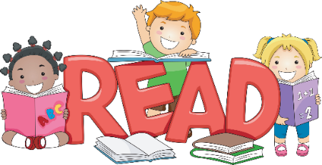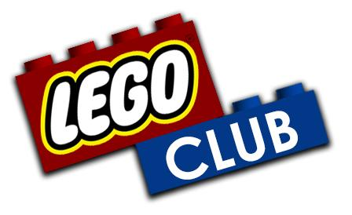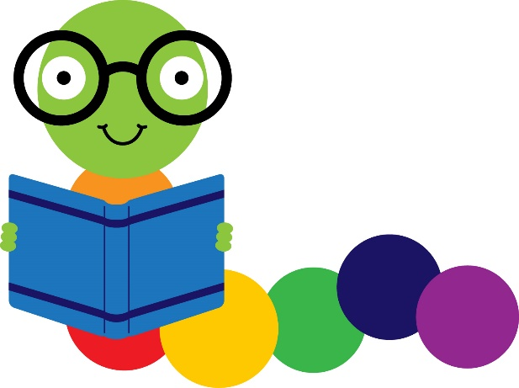

More information regarding the days and times of story time will be posted soon. Please check the library Facebook page or website for additional information.

**Story Time Coming Soon!**

**Early Literacy Rhyme the Month**

**I Have 10 Fingers**

I have ten little fingers, and they all belong to me. (hold hands out in front)

I can make them do things, would you like to see?

I can shut them tight. (make a fist)

I can open them wide (spread fingers out)

I can put them together (clasp hands together)

I can make them hide (put hands behind back)

I can make them fly high (raise hands and wiggle fingers overhead)

I can make them fly low (lower hands to feet and wiggle fingers)

I can fold them like this and hold them just so. (fold hands in lap)

**Developmental Tip**

The coordination of small muscles in the hands and fingers is called “fine motor movements.” Children need fine motor skills to write, cut, use a fork or spoon, zip up a jacket, button a shirt, move puzzle pieces and perform other tasks. A child who does not have well-developed fine motor skills may have difficulty learning to write or doing other important tasks. Reciting fingerplays helps your child develop important skills.

Source: http://www.mgol.net/resources/nursery-rhymes/rhyme-of-the-month/pastrotm/

Drop in between 6:00 and 7:30 pm on Monday, January 8th for LEGO Club. LEGO Club is held the 2nd Monday of each month. Bricks are provided. This club is for children ages 5 and up.

Children’s Corner