A Variety of Programs

Paul Smith Library is proud to offer a variety of programs for adults. Come in to

**Do you want to see your content here? We want to publish you!**

Write a poem, short story or a book review and we will consider adding it to one of our upcoming newsletters. Drop your submissions off at the Library for the Director, or email them to mlefler@yorklibraries.org

Patron Nook

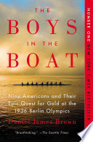 learn and socialize with other library patrons.

**Evening Book Group**

This book group is held from 6:00-7:00pm on the third Wednesday of each month. To register for the group, please call the library or email [llucas@yorklibraries.org](mailto:llucas@yorklibraries.org)

**December Book:**

*Skipping Christmas* by John Grisham

**January Book:**

*The Boys in the Boat: Nine Americans and Their Epic Quest for Gold at the 1936 Berlin Olympics* by Daniel Brown

**Coffee & Coloring**

This adult program provides a time for community members to come in and unwind. Enjoy a cup of coffee and relax while coloring. This is a great opportunity to meet up with friends or meet new people. Our sessions are held on the second Wednesday of each month as a drop-in session from 5:00-7:00pm. Each month has a different coloring theme. Coffee and coloring supplies are provided by the library, but feel free to bring your favorite supplies.

**Friday Book Club**

This book club is held on the second Friday of each month from 1:00-3:00pm. If you have read the book but are not a member of the club, you are welcome to join us for the discussion. To register for the club, please call the library or email [mlefler@yorklibraries.org](mailto:mlefler@yorklibraries.org)

**December Book:**

*Hillbilly Elegy* by J.D. Vance

**Adult Storytime**

Who doesn’t love a good story? At Paul Smith Library, story time isn’t just for kids anymore! Bring your lunch and enjoy listening to a story. This is an adults program held on the third Mondayof each month at Noon. No registration is required.

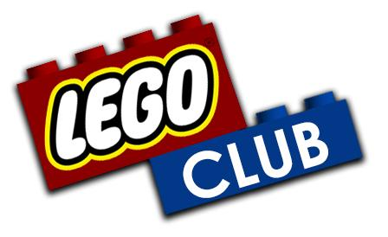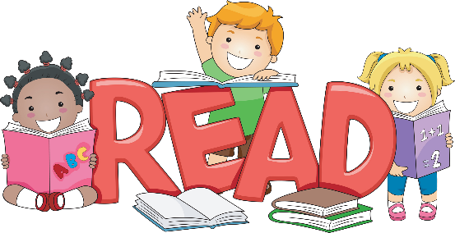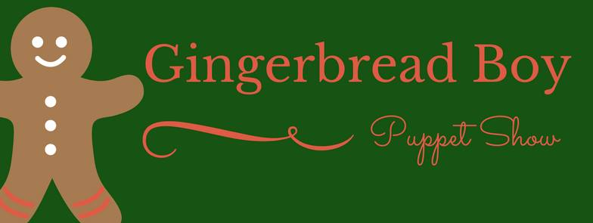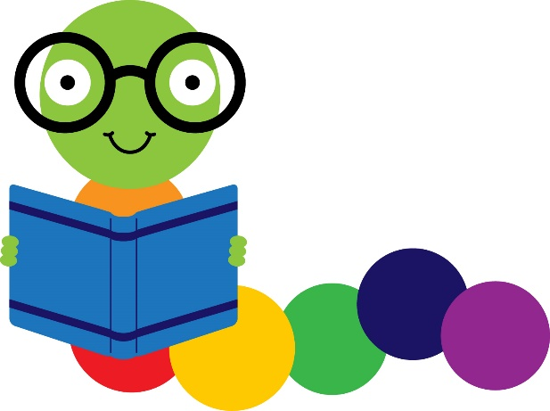

Drop in between 6:00 and 7:30 pm on Monday, December 11 for LEGO Club. LEGO Club is held the 2nd Monday of each month. Bricks are provided. This club is for children ages 5 and up.

**Early Literacy Tips of the Month**

* Every time you read the same book, your child gets something new out of it. Repetition is necessary and good.
* Reading is the single best thing you can do to help your child be a lifelong learner!
* One way that children become interested in reading is seeing their parents read. Try to find time to make reading a priority for everyone at home so that your children will be inspired to read.

Children’s Corner

There will be no story times during the month of December. Although there will be no formal programing, families are encouraged to stop by during their regular story time for an informal playgroup. The toys will be out for children to play with.

**Story Time Update**

It's time for our annual tradition: Gingerbread Boy Puppet Show! This will be Miss Dawn's last year presenting this show. Don't miss out! Free tickets available at the front desk.

**Showtimes**

December 4, 10:30am

December 4, 7:00pm

December 5, 10:30am