

Announcements

**New Staff Picks on Display**

Are you looking for new book recommendations? Check out our new winter Staff Picks on display at the Library. These books have been read and enjoyed by Paul Smith Library staff.



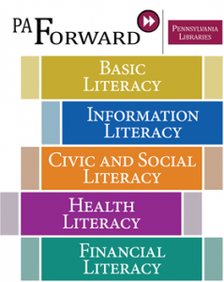

**Your Unwanted Glasses Will Help Someone See Better**

Donate your old, unused glasses to the Lion’s Club Recycle for Sight program. A donation box is located in the vestibule.

**A New Book is Never Far Away**

Are you in need of new books for your Kindle or e-reader? York County Libraries offers a great selection of ebooks for you to access at home and on the go. Visit yorkebranch.overdrive.com to download your next novel today!



**Need Help with Your Electronics?**

The YCL Tech GURU will be at Paul Smith Library on the first Wednesday of each month from 1:30-3:30pm. Stop by on Wednesday, December 6th for assistance with your Laptop, Kindle and more.

**Staff**

**Michele Lefler, Director**

[mlefler@yorklibraries.org](mailto:mlefler@yorklibraries.org)

**Louann Lucas, Volunteer Coordinator**

[llucas@yorklibraries.org](mailto:llucas@yorklibraries.org)

**Dawn Stockbridge, Youth Services Director**

[dstockbridge@yorklibraries.org](mailto:dstockbridge@yorklibraries.org)

**Anna Paules, Library Assistant & Inter-Library Loan**

[apaules@yorklibraries.org](mailto:apaules@yorklibraries.org)

**Library Assistants**

**Lauren B.**

**Carol F.**

**Katie F.**

**Candace S.**

**Hours of Operation**

**M/T/W: 10am - 8pm**

**TH/F/SAT: 10am – 5pm**

**Sun: Closed**

[www.yorklibraries.org/paul-smith](http://www.yorklibraries.org/paul-smith)

**Search the library catalog, renew books, place holds and more!**

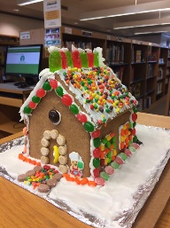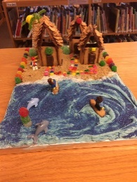

**Calling All Gingerbread Architects!**

Children of all ages are invited to participate in Paul Smith Library’s annual Gingerbread House Festival. The Festival will run November 27 through December 22. All entrants will receive one free movie rental from Paul Smith Library.

**Gingerbread House Building Codes**

* There is no entry fee.
* All building supplies are the responsibility of the participants.
* All entries must use a sturdy base within the dimensions of 11”x17”. Competitor’s name should be labeled underneath the base.
* Prepackaged Gingerbread kits may be used, but decoration should be the original work of the participant.
* Photographs of entries may be posted on the Library’s Facebook page. Participant’s names will not be posted.
* Gingerbread houses must be picked up before 4:00pm on December 22, or each house will be removed and disposed of by Library staff.

**Author to Visit Paul Smith Library**

On December 5, at 6:00pm, the Library will host Author William Alan Larsh (author of “L’Archeveque”). He will share his new book, “The FBI- They Eat Their Young”. This book is a detailed memoir of an FBI agent’s career. The book provides the reader with the unique and often amusing story of one agent’s journey from his first day of work until his retirement. Copies of the book will be available for a discount price of $12 following the presentation.

|  |  |  |
| --- | --- | --- |
| Dec. 4 | Puppet Show | 10:30am |
| Dec. 4 | Puppet Show | 7:00pm |
| Dec. 5 | Puppet Show | 10:30am |
| Dec. 5 | Author Talk & Book Signing | 6:00-7:00pm |
| Dec. 6 | Tech Guru | 1:30-3:00pm |
| Dec. 8 | Friday Book  Club | 1:00-3:00pm |
| Dec. 11 | LEGO Club | 6:00-7:30pm |
| Dec. 13 | Coffee & Coloring | 5:00-7:00 pm |
| Dec. 18 | Adult Story Time | 12:00-1:00pm |
| Dec. 20 | Evening Book Club | 6:00pm |
| Dec. 23 | Library Closed |  |
| Dec. 25 | Library Closed |  |
| Dec. 26 | Library Closed |  |
| Dec. 30 | Library Closed |  |
| Jan. 1 | Library Closed |  |

**Calendar of Events**

**PAUL SMITH PRESS**

*Your Community Link*

PAUL SMITH LIBRARY NEWS, INFORMATION & EVENTS

DECEMBER 2017